1. I am using the “pandas” library from Python for **Data Exploration & Cleaning. Check "**[**Task_1.ipynb**](https://drive.google.com/open?id=1sWTqs73nDmxB4mQvMYaVuzgdG8TaU6f8)**" (open this link with google colab)**

At first, I checked for any missing values, duplicates, or data type inconsistencies using the isnull() function from pandas. The dataset did not contain any duplicates or inconsistencies, nor any (necessary) missing values.

If any duplicate values were found, we could use drop_duplicates() to remove those extra rows. For missing values, we could use interpolate(), which applies a linear method based on surrounding data points to fill in missing values.

#### Dataset Summary:

<class 'pandas.core.frame.DataFrame'>

RangeIndex: 20000 entries, 0 to 19999

Data columns (total 14 columns):

# Column Non-Null Count Dtype

--- ------ -------------- -----

0 user_id 20000 non-null int64

1 install_date 20000 non-null object

2 last_active_date 20000 non-null object

3 subscription_type 20000 non-null object

4 country 20000 non-null object

5 total_sessions 20000 non-null int64

6 page_views 20000 non-null int64

7 download_clicks 20000 non-null int64

8 activation_status 20000 non-null int64

9 days_active 20000 non-null int64

10 pro_upgrade_date 20000 non-null object

11 plan_type 20000 non-null object

12 monthly_revenue 20000 non-null int64

13 churned 20000 non-null int64

dtypes: int64(8), object(6)

memory usage: 2.1+ MB

#### Distribution of Free vs. Pro Users:

subscription_type

Free 79.855%

Pro 20.145%

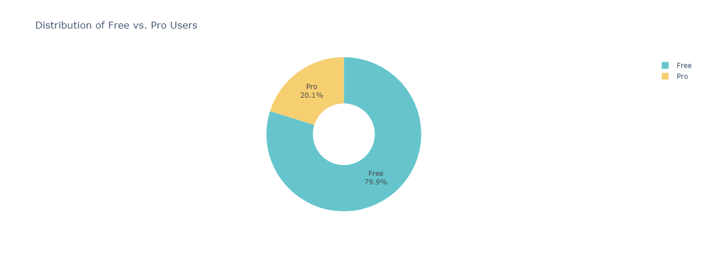

1. **Check "**[**Task_2.ipynb**](https://drive.google.com/open?id=1B6GPofWrI_rSlOIKiyUNjguZRIXAWJjJ)**"**

#### Average Number of Sessions for Free vs. Pro Users:

subscription_type

Free 76.08

Pro 154.68

#### Top 5 Most Active Users Based on Total Sessions:

user_id total_sessions subscription_type

188 189 300 Pro

821 822 300 Pro

1571 1572 300 Pro

2456 2457 300 Pro

3348 3349 300 Pro

#### Top 5 Countries with the Highest Engagement:

country

India 272,202

Germany 266,319

Canada 264,217

USA 261,635

France 259,495

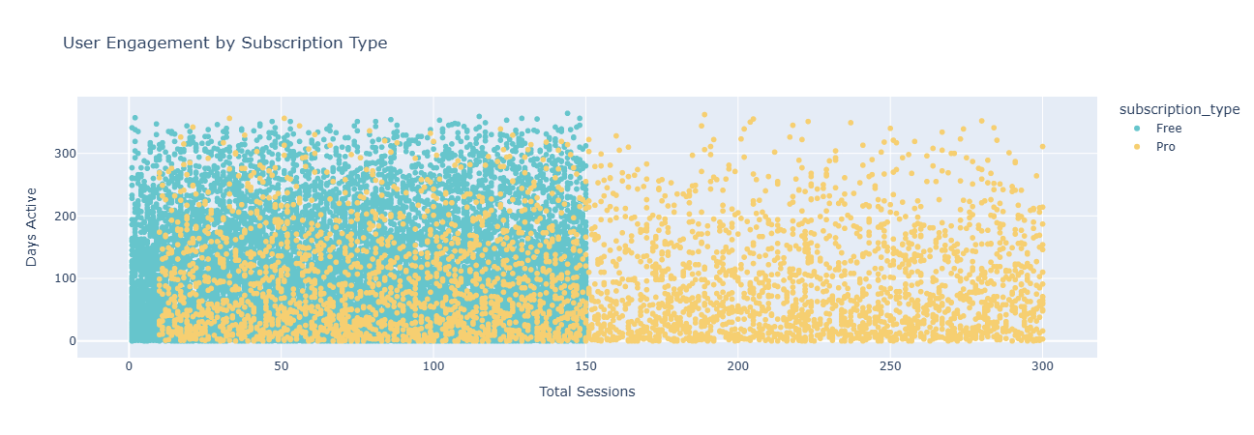

1. **Check "**[**Task_3.ipynb**](https://drive.google.com/open?id=1bJk45nKI9puv2CS-IPuWeMtWVpJ1v74h)**"**

#### Overall Churn Rate for Free vs. Pro Users:

subscription_type

Free 28.60

Pro 28.25



#### Correlation of Features with Churn:

churned 1.000000

user_id 0.012038

download_clicks 0.000974

total_sessions -0.000273

page_views -0.005605

activation_status -0.005823

monthly_revenue -0.008328

days_active -0.617213

#### Top 3 Factors Contributing to Churn:

['user_id', 'download_clicks', 'total_sessions']

**Churn Trends: Free vs Pro users**

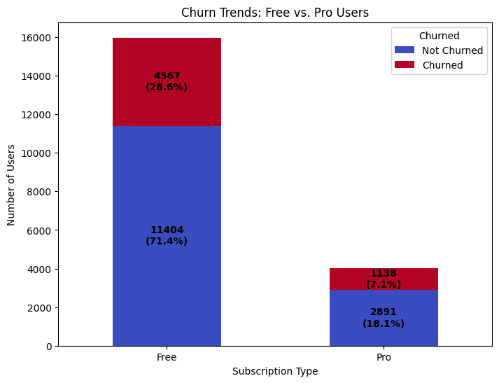

1. **Check "**[**Task_4.ipynb**](https://drive.google.com/open?id=1Uckor6b4OXoKV-W1epfQxXkVZfwCZ1Cz)**"**

#### Percentage of Users Who Upgraded from Free to Pro: **20.14%**

#### Total Monthly Revenue from Pro Users: **$235,481.00**

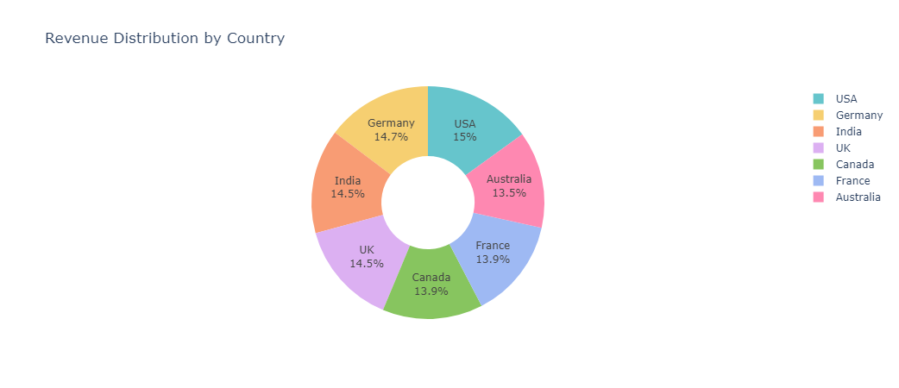

#### Average Time to Upgrade (in Days) by Country:

UK 87.90

USA 90.24

France 91.16

Germany 91.53

India 92.58

Canada 93.57

Australia 93.68

1. **Check "**[**Task_5.ipynb**](https://drive.google.com/open?id=13tK2hLlY63Pq6XUujgpDZqbRWe_aC2Zu)**"**

**1. Three Strategies to Reduce Churn**  
  
We can divide churned users into three categories:

Low Engagement, Medium Engagement, & High Engagement based on total_sessions, page_views, days_active  
  
  
1. Low Engagement Users may need re-engagement campaigns. (e.g., personalized emails, notifications etc.)

2. Medium Engagement Users may benefit from targeted upsells, because they have already spent more time than the Low Engagement Users, so they may need some little push.

3. High Engagement Users may have churned due to specific issues (e.g., pricing, feature gaps). We should have an option for the users to give feedback, so that we can analyse what's the main issue, such as pricing or any feature gaps, so that we can work on to get things right, because these are the high value users, we should keep them active.

Besides these specialised actions, we should take other text book actions to reduce the churned rate.

**2. Ways to Increase Free-to-Pro Conversions**

1. We can target those free users who have pro-like behaviour based on total_sessions, page_views, days_active, but still, they didn't subscribe to any pro plan, we can highlight the Value of Pro Features for them. Because, Users may not fully understand the benefits of upgrading to Pro. And if needed we can offer time-limited discounts or free trials to encourage upgrades.
2. We can simplify the Upgrade Process, because users who click "Download Pro" (download_clicks = 1) but do not upgrade may face barriers in the conversion process. We can use exit-intent pop-ups to capture users who are about to leave without upgrading. We can showcase other user's testimonies to demonstrate how Pro features have helped them.

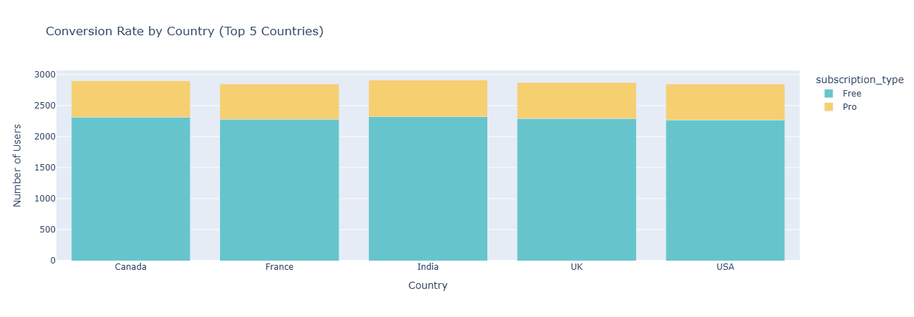

**3. Potential Market Expansion Opportunities**

**Top 5 high-engagement countries based on total_sessions:**

**country**

India 272202

Germany 266319

Canada 264217

USA 261635

France 259495

**Name: total_sessions, dtype: int64**

**Top 5 underpenetrated markets based on total_sessions:**

**country**

**Australia 255270**

**UK 259152**

**France 259495**

**USA 261635**

**Canada 264217**

**Name: total_sessions, dtype: int64**

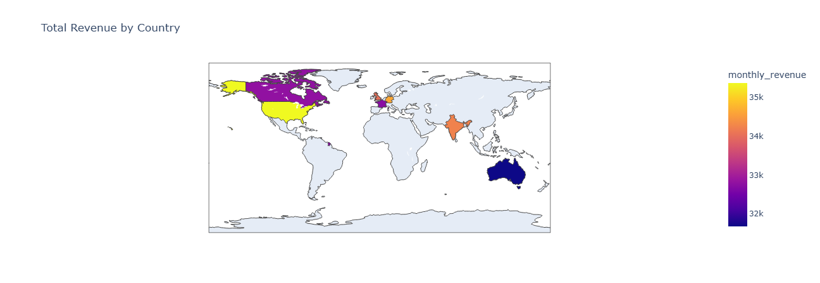

1. **Check "**[**Task_6.ipynb**](https://drive.google.com/open?id=1y2azRpXB9ENRWLCmcaMoFHK0x6FmGEwE)**"**

#### Impact of a 10% Increase in Landing Page Conversion Rate:

* **Current Conversion Rate:** 40.29%
* **New Conversion Rate:** 44.32%
* **Estimated Additional Pro Upgrades:** 403

**Contingency Table:** [[4744 256]

[4716 284]]

* Chi-square statistic: 1.43
* P-value: 0.2322  
    
  The result is not statistically significant. The new landing page does not improve conversions. Because P-value is > 0.05

#### Three A/B Test Ideas to Improve Conversion Rate:

1. **CTA Button Design & Placement:** Test different colours, sizes, and placements.
2. **Simplified vs. Detailed Pricing Page:** Test a minimal version with FAQs.
3. **Social Proof & Testimonials Placement:** Add reviews near CTAs.

**Key Performance Indicators (KPIs):**

* **Churn Rate:** 28.52%
* **Conversion Rate (Free to Pro):** 25.23%
* **Customer Lifetime Value (CLV):** $701.36

1. **Check "**[**Task_7.ipynb**](https://drive.google.com/open?id=1RwjrJ59O2fdRbnFsVyYO5HC-Tb4fzT_P)**"**Key Performance Indicators (KPIs):

* **Churn Rate:** 28.52%
* **Conversion Rate (Free to Pro):** 25.23%
* **Customer Lifetime Value (CLV):** $701.36

#### Actionable Growth Strategies:

a. Improvement on Onboarding and Activation: Users who do not activate the plugin (activation_status = 0) are more likely to churn and less likely to upgrade.

1. We can simplify the activation process with clear instructions and tooltips.
2. We can use behavioural triggers (e.g., pop-ups, emails) to guide users through activation.
3. We can offer incentives (e.g., free trials, discounts) for users who activate the plugin.

b. Targeted Upselling Campaigns: Users who click "Upgrade to Pro" but do not upgrade represent a significant opportunity for conversion.

1. We can use email campaigns to highlight the benefits of Pro features for users who clicked "Upgrade to Pro".
2. We can offer time-limited discounts or free trials to incentivize upgrades.
3. We can use exit-intent pop-ups to capture users who are about to leave without upgrading.

**Measuring Success:**

* 1. Comparing activation & churn rates before and after implementation.
  2. Using A/B testing
  3. Tracking revenue and CTR over time.

1. **Data Storytelling & Visualization** [**dashboard.py**](http://dashboard.py)**"  
     
   Run in your cmd prompt: Python dashboard.py**